***Health Insurance Cost Prediction Using Watson Auto AI***

**Index:**

1. INTRODUCTION

* Overview
* Purpose

1. LITERATURE SURVEY

* Existing Problem
* Proposed Solution

1. THEORITICAL ANALYSIS

* Block diagram
* Hardware/Software designing

1. EXPERIMENTAL INVESTIGATIONS
2. FLOWCHART
3. RESULT
4. ADVANTAGES/DISADVANTAGES
5. APPLICATIONS
6. CONCLUSION
7. FUTURE SCOPE
8. BIBLOGRAPHY

APPENDIX

* 1. **INTRODUCTION**
* **Overview:**

                 I had done my internship on machine learning with python in this internship I have learned what is the use of machine learning  and what are its applications ML is the sub topic of AI and the internship is based on how we can study ML with python.

python programming the basics of the course about python functions, exceptional handling and OOPS concept.

ML uses the approach with the help of algorithms and statistic to make future decisions or predictions to solve a problem in ml inputs are called as features and outputs are called as labels.ML is mainly used for building a model where data and the output are given to the system or algorithm and model is generated by implementing 5 steps ML model can be made collection of data, data wrangling where we can filter the data, Analyze the data, train and test the algorithm, deployment testing the data with web applications.

* **purpose:**

**problem:** Health Insurance Cost Prediction using Watson Auto AI

**solution:** This model is to predict the cost for health Insurance Company.

* 1. **LITERATURE SURVAY:**
* **Existing problem:**

Health Insurance companies have a tough task at determining premiums for their customers. While the health care law in any country does have some rules for companies to follow to determine premiums, it’s really up to the companies on what factor/s they want to hold more weightage. Companies should know the most important factors and how much statistical importance do they hold.

* **proposed Solution:**

The main aim of this project is to create a model based on statistically significant factors (independent variable) which will affect premiums charges (dependent variable) by an insurance company. In this project we are using Multi Linear regression for the accurate prediction. An application is also build in Auto AI Service in IBM Cloud which can be interlinked with the model so as to view the result on UI based on input parameters.

* 1. **THEORITICAL ANALYSIS:**

**BLOCK DIAGRAM:**

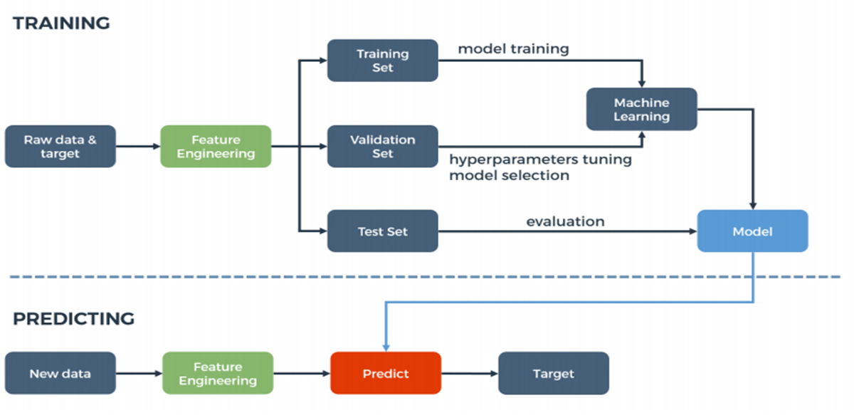

* **HARDWARE/SOFTWARE DESIGN:**

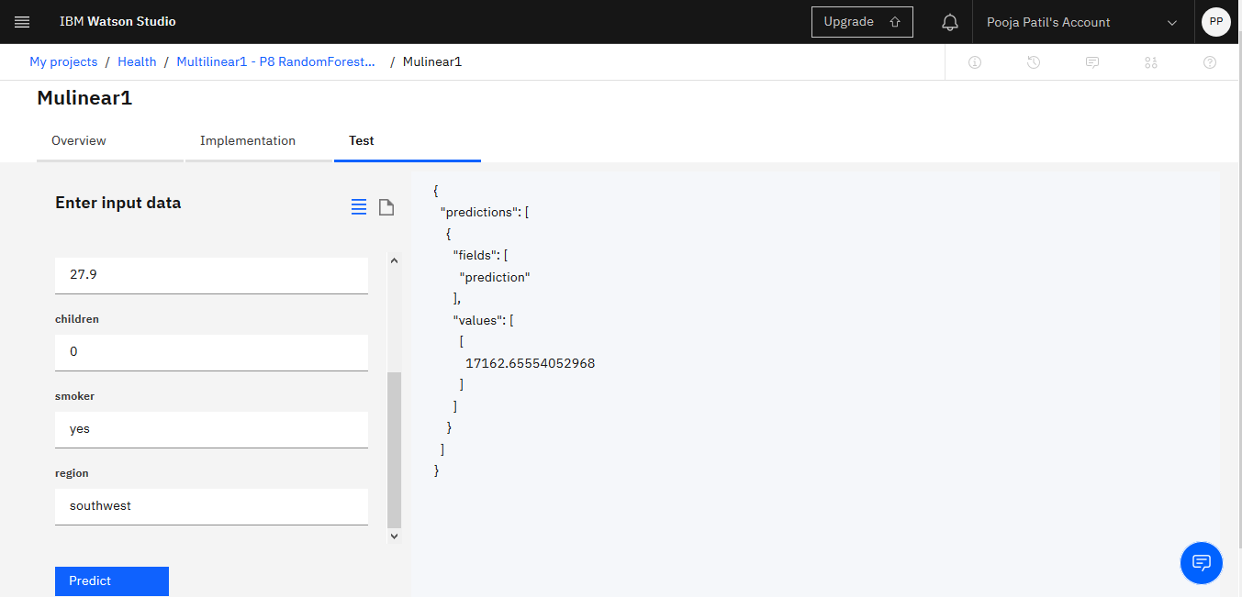

* 1. **EXPERIMENTAL INVESTIGATIONS:**

1. Collection of data set from Kaggle.
2. On IBM Watson studio machine learning using auto ai build a model to predict cost of health insurance companies .

* 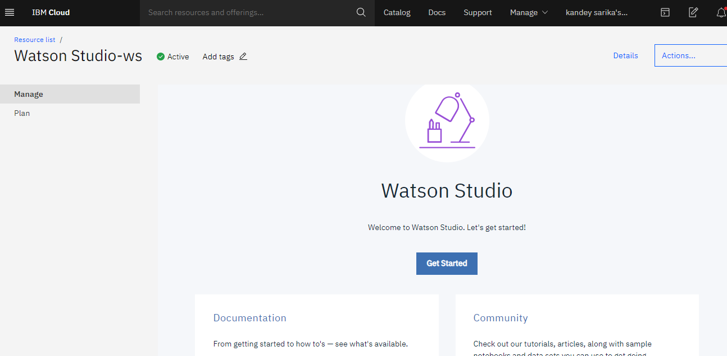first create account on IBM Watson studio.
* 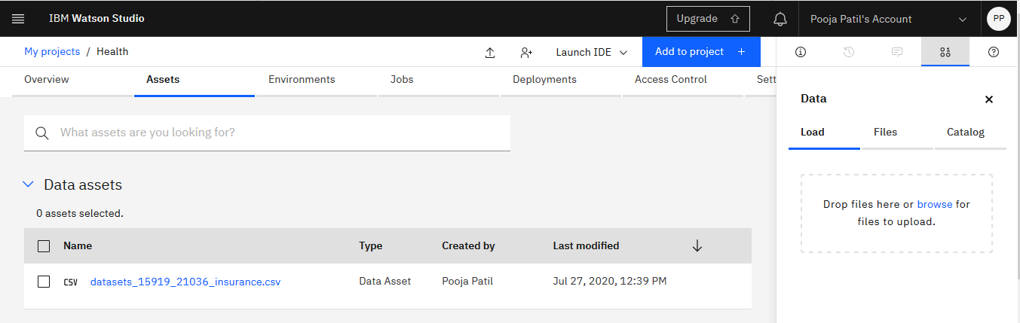using  add to project choose auto AI and then upload the data set from Kaggle into the data assets.
* deploy the model and test with the various values .



* create a node red app with credentials cloud foundry app.

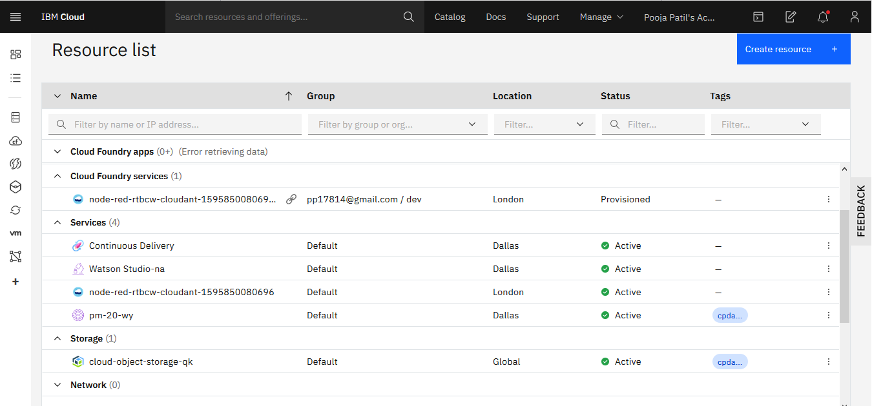

* 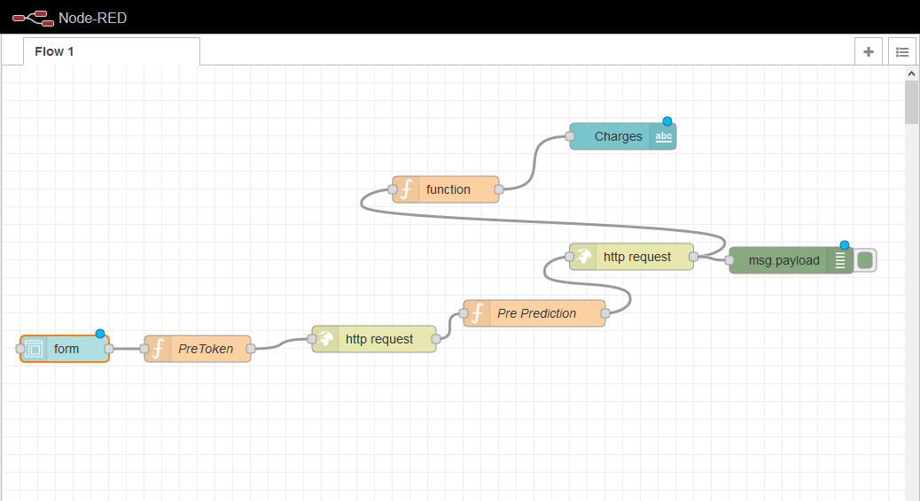create a NODE-RED flow to predict values
* deploy the flow model and put values in it to predict the model.

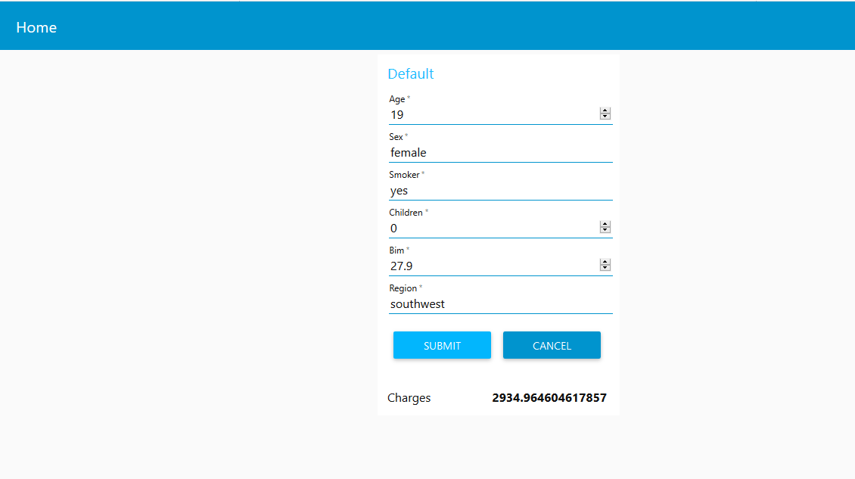

* 1. **FLOWCHART:**

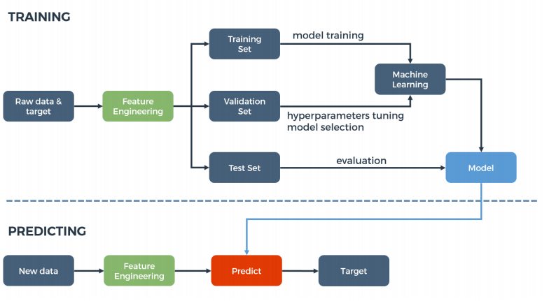

* 1. **RESULT:**

The Health Insurance Cost prediction using Watson Auto AI with the help of machine learning to predict the cost to be used for health insurance companies .

* 1. **ADVANTAGES:**

Rising costs of healthcare as well as the evident need for adequate healthcare today makes health insurance a definite must. anticipating demand will help you tweak your processes to increase efficiency all along the supply chain. Because you’re better able to predict what customers will want and when they’ll want it, you may also be able to decrease excess inventory levels, thus increasing overall profitability.

**DISADVANTAGES:**

One of the main disadvantages of having health insurance is the cost. Health insurance can be very costly even for those that have a health insurance plan through their employers. Costs may be so high that many end up struggling to make payments. This can be quite challenging for those who have low incomes or are self-employed. Health care coverage for families may cause an added financial burden.

* 1. **CONCLUSION:**

              Here by I conclude learned how to use IBM Watson and juypeter anaconda is very easy to access and understand and I gained knowledge and skills in the project this internship is very use full and using bootcamps were help full in the completion of the project.

This project helps to predict cost for health Insurance Companies. The internship was also good to find out what my strengths and weaknesses. This helped me to define what skills and knowledge I have to improve in the coming time.

* 1. **FUTURE SCOPE:**
* Lifestyle related ailments are common these days
* Healthcare is becoming increasingly expensive
* It is difficult for a family to quickly arrange for huge amounts of money required for treatment
* Most of the savings of a family are in the form of fixed assets, which cannot be liquidated quickly

**10. BIBLOGRAPHY:**

☆ Kaggle for downloading the dataset.

☆ Smartbridge bootcamp to learn how to work on IBM Watson studio